street services performance

performance dashboard report

Prepared by

Jemin Gohil

Yong Guan

Yana Saakyan

May 10, 2017

# need

Build a real-time dashboard for the Bureau of Street Services to evaluate the performance Pavement Preservation services within an arbitrary range of time.

## Specific Requirements for the Dashboard

1. To create an automated process for recording service statistics and instantly reflecting them on the Dashboard
2. To allow for the evaluation of service performance within an arbitrary range of dates
3. To recommend new metrics to evaluate the performance of pavement preservation services

# data

The Bureau of Street Services has provided the following data used or considered in the creation of the Dashboards:

1. Street services crew performance records for the month of December 2016
2. Partial street services crew performance records for the month of October 2016
3. Samples of existing Street Services reports
4. Samples of existing dashboards used by the Street Services Bureau (MyLA 311 3DI)

# architecture

Taking into consideration the tool suggestions from the Bureau of Street Services, the following data flow and architecture have been used:



Tableau

Google Sheets

Google Forms

## Google Forms

Google Forms have been selected because it is an open source software with a simple interface that can be used from both a desktop and a mobile device. Google Forms also seamlessly connect to Google Sheets to store collected data.

## Google Sheets

Google Sheets have been used because it is open source software already used by the Bureau of Street Services. The Google Sheet contains only raw data, specifically:

* Historic data (records from October and December 2016)
* Live data (records from Google Form)
* Weather data (obtained using Open Weather Map API and Google Script)
* List of Crew Supervisors

## Tableau

Tableau was selected for its robustness as a data analytics and visualization tool and at the recommendation of the Bureau of Street Services. Tableau Workbook is connected ‘live’ to the Google Sheet. All calculated fields are stored in Tableau Workbook only.

For details on data architecture format, please see Appendix I: Architecture and Tools.

DAShBOARDS

All dashboards are prepared using Tableau software. Each Dashboard features an arbitrary date range picker as well as filter by a task type.

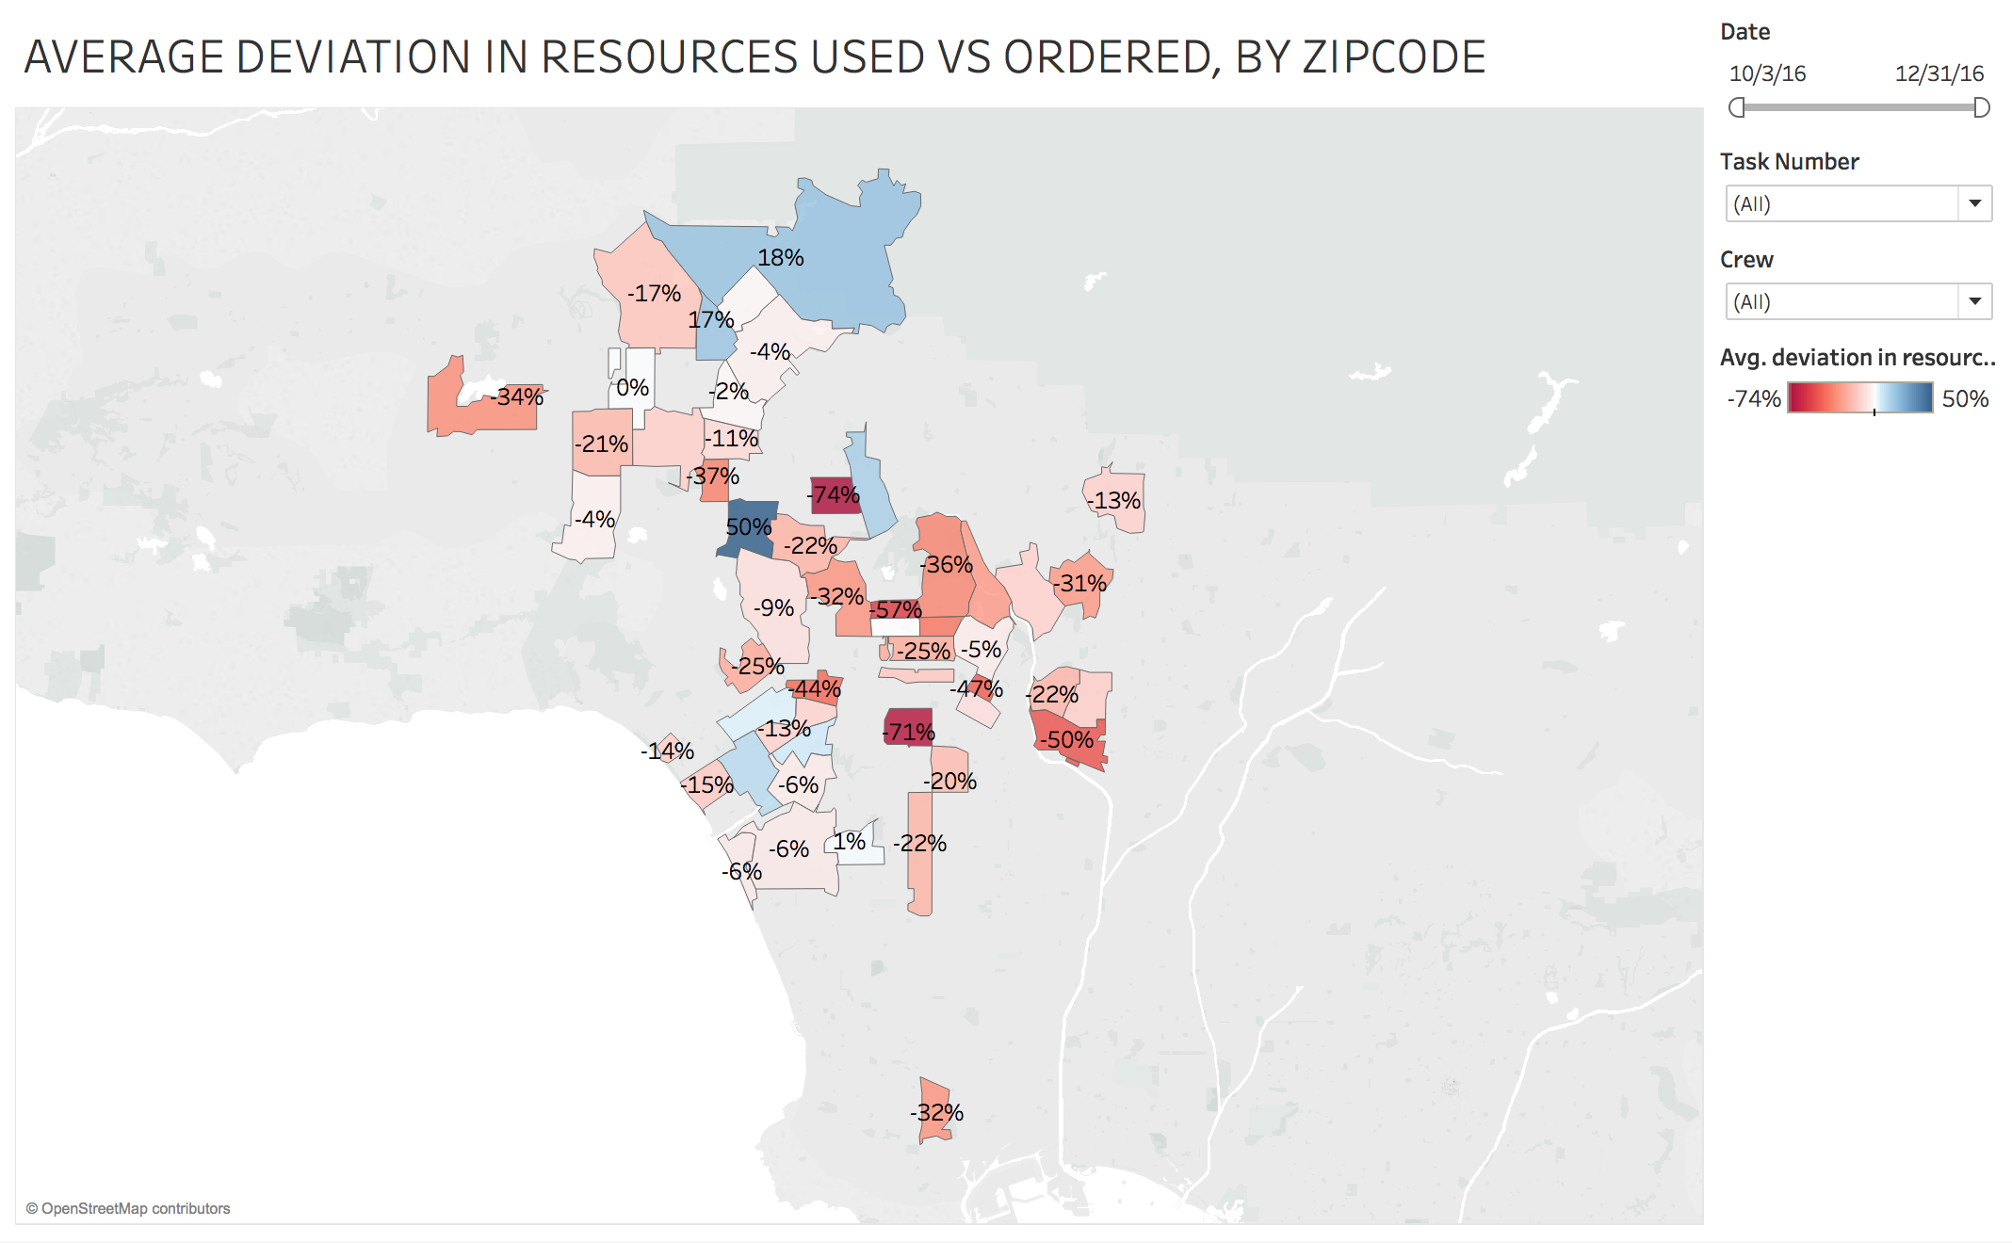

# crew performancE dashboard

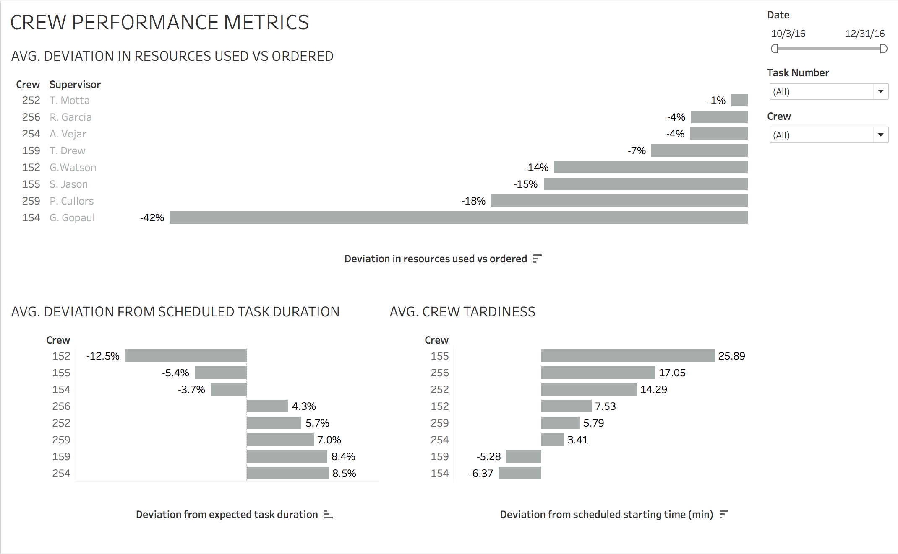

Taking into consideration the focus of existing Street Services reports on crew performance, the first dashboard focuses on observed and new metrics evaluating crew performance.

1. The top chart demonstrates how much a crew over- or under-estimates the resources[1] needed for a task. In this demonstration based on the historic data, we can observe, the crews order more resources than they use on average, with Crew 154 ordering nearly twice as much as usually required.[2]
2. Metrics assessing crew time are proposed in the lower half of the Dashboard. As demo charts reveal, Crew 152 is the most efficient in completing the tasks under the schedule time. Crew 155, on the other hand is, on average, 25 min late to their tasks. Our team recommends exploring potential causes of deviation in crews’ timing and adjust policies to encourage healthier habits and discourage bad ones.

# geographical assessment dashboard



The second dashboard we recommend explores geographic patterns in the efficiency of resources usage. It is a map visualizing how the resources used deviate from resources ordered by a zip-code area of Los Angeles. A geographical assessment of Street Services performance can be a powerful tool to identify potential causes of inefficiencies in resource utilization.

In this demo dashboard, there are no strong patterns; however, patterns might emerge once more data is introduced.

We recommend for the Street Service Bureau to analyze the location-based performance patterns in relation to the location of asphalt factories to analyze if there is any relationship between over- or under-estimation of needed resources and their distance from the factories.

# weather effects dashboard

Understanding the impact weather has on the amount of resources required to perform a street service can help the Bureau to anticipate resource necessities more effectively. This dashboard presents how 4 out of 7 collected weather metrics relate to deviation in resources used vs. the amount ordered.

Although no strong patterns have been revealed, our team wants to draw attention to few insights:

1. The amount of materials needed either approached or went over the anticipated amount as the amount of precipitation increased
2. On the days when the temperature was above 65 Fahrenheit, the crews tended to use significantly less resources than ordered (>20%)

Collection of larger amount of data might reveal further insights into the effects of weather on resource usage.

# causes for delay dashboard

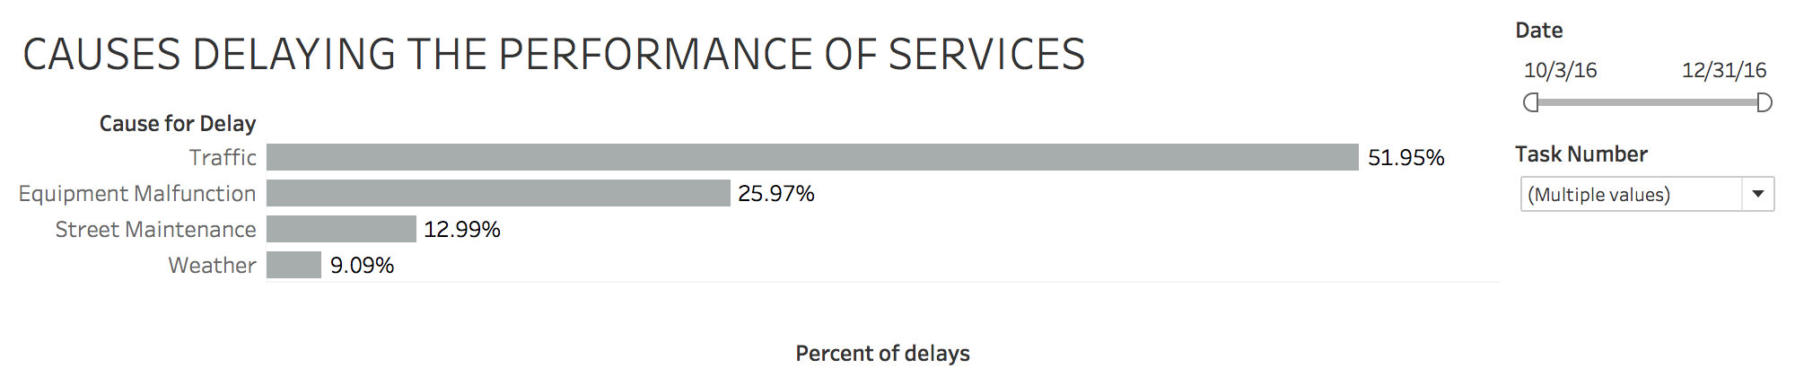

Lastly, we recommend the Street Services Bureau to analyze the explicit causes for the delays or cancellations of services. Understanding the causes might help the bureau to:

1. Find solutions to mitigate them
2. Prioritize which causes require immediate attention.

Our team had added a “cause for delay” field with suggested list of causes. For the purposes of demonstration, the team had assigned assumed cause to a service delay. In this demonstration, traffic causes the majority of delays.

# Conclusion

In response to the need for an automated, real-time Dashboards evaluating the performance of Street Services crews, our team recommends the following:

1. An architecture consisting of Google Forms connected to Google Sheets, which collects and feeds data into a Tableau Software. Such architecture allows to evaluate service performance within an arbitrary range of time, collect and feed data in real-time, and create visually-effective dashboards that can incorporate a wide range of new creative metrics.
2. In addition to the existing crew performance metrics, we also propose the following:
   1. Analysis of crew timing, including patterns in tardiness and performing tasks over or under the amount of time scheduled for the service
   2. Geographical assessment of the deviation of resources used from ordered amount and its potential correlation with the distance from asphalt factories
   3. Weather effects on the deviation of resources used from the ordered amount
   4. Patterns in causality of service delays and cancellations.

APPENDIX

# Appendix I: architecture and tools

## Google Forms

Source: <https://docs.google.com/forms/d/1BuNgv218FojXRBKyKAOK76UmUdWVTiR_zvlx8Kb1Hpk/edit?usp=drive_web>

A Google Form had been created to be used to capture the details of a service at the time it is performed.

* The form can be used from a mobile device or a desktop computer; via browser or a Google mobile application.
* Google Form requires internet connection to submit the results to the Google Sheets. The results are submitted instantaneously.
* Fields necessary for the successful evaluation of the Street Services performance are marked “required”.
* Within a form, the numeric-based fields are limited to accept only numeric inputs (e.g. tonnage ordered, tonnage used, etc.)
* Inputs with limited options are designed as drop-down fields to reduce possibility of an error and to make the process easier for the person filling the form (e.g. task numbers, crew numbers).
* New inputs were introduced to the form to allow for new metrics: zip code (to evaluate geographic patterns), cause for delay (to asseses weather effects on resources utilization).
* Our team recommends for the “Cause of delay” options to be reviewed and revised according to Street Services Bureau knowledge of potential causes for services delays and cancellations.

## Google Sheets

Link to the source: <https://docs.google.com/spreadsheets/d/1abG3EZGHcCDgNHBbc-GEjIr1mF7QefpevELgsvJc7b8/edit?usp=drive_web>

With consideration for the provided Google Sheets architecture, a new Google Sheet was designed as a single destination for all Street Services records collected via 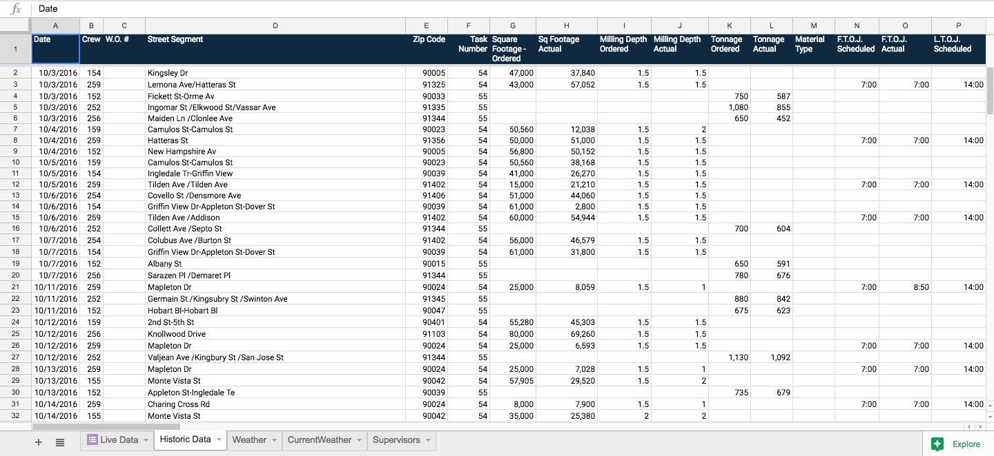Google Form.

* All available historic data (i.e. October and December 2016) was collected under “Historic Data” tab.
* New data from Google Forms will be recorded under “Live Data” tab.
* Both historic and new data tabs follow the same data format and can be combined as a union in Tableau Workbook for future analysis
* Both historic and new data tabs feature only raw data (all calculated fields reside in Tableau only)
* 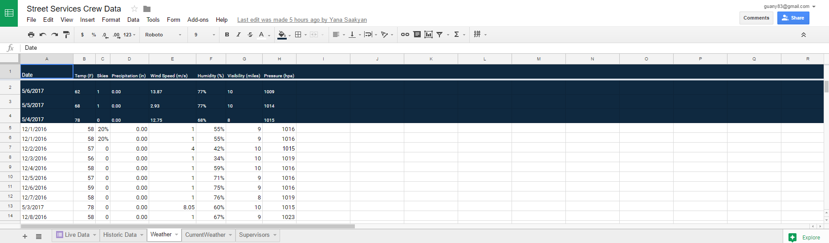A Google Script has been created to capture current weather (under “Current Weather” tab) and record it daily (under “Weather” tab) [Openweathermap.org](http://openweathermap.org) API is used to collect weather data. The time the script captures weather record is between 11am and noon, which appeared to be the most common time for street services. Weather data includes:
  + ski clarity (percentage)
  + temperature (Fahrenheit)
  + wind (miles / second)
  + pressure (hpa)
  + humidity (%)
  + precipitation (inches)
  + visibility (miles)

## Tableau

At the suggestion of the Street Service Bureau team, Tableau has been selected as the analytical and visualization tool[3].

* The Google Sheet is connected to Tableau workbook and is update live
* The historic data (October and December 2016) is utilized in the demo Dashboards. We recommend the Bureau to merge it with the live data via union once the new data is added using Google Forms
* Weather data is ‘left-joined’ to the data on street service performance (i.e. Historic and Live Data tabs)
* Supervisor table is ‘left-joined’ with the crew on street service performance (i.e. Historic and Live Data tabs)
* Calculated fields from the original Pavement Preservation Reports (e.g. percentage of tonnage actual vs ordered, time spent on the task vs scheduled) are re-created in Tableau Workbook
* New calculated fields are added to enable new metrics, e.g.:
  + Milling AvO[4]: Square footage actually used vs ordered amount
  + Paving AvO: Tonnage actually used vs ordered amount
  + Scheduled Duration (min): Scheduled LTOJ - Scheduled FTOJ, in minutes
  + Actual Duration (min): Actual LTOJ - Actual FTOJ, in minutes
  + Duration, Actual vs Scheduled (min): Actual Duration - Scheduled Duration
  + Combined AvO: A column combining the estimates of tonnage and milling (actual - ordered) in order to summarize resources used vs planned.
  + FTOJ AvS: First time on job, actual vs. schedule - to estimate the tardiness of crews

1. Resources are a combination of milling square footage (actual vs. ordered) and pavement tonnage (actual vs. ordered)
2. Name of supervisors are given as reference to a party responsible for the crew performance.
3. Tableau Workbook can be accessed using a Google account with which Google Sheet had been shared (e.g. Hunter Owens).
4. *AvO = Actual vs. Ordered*